Interface spec

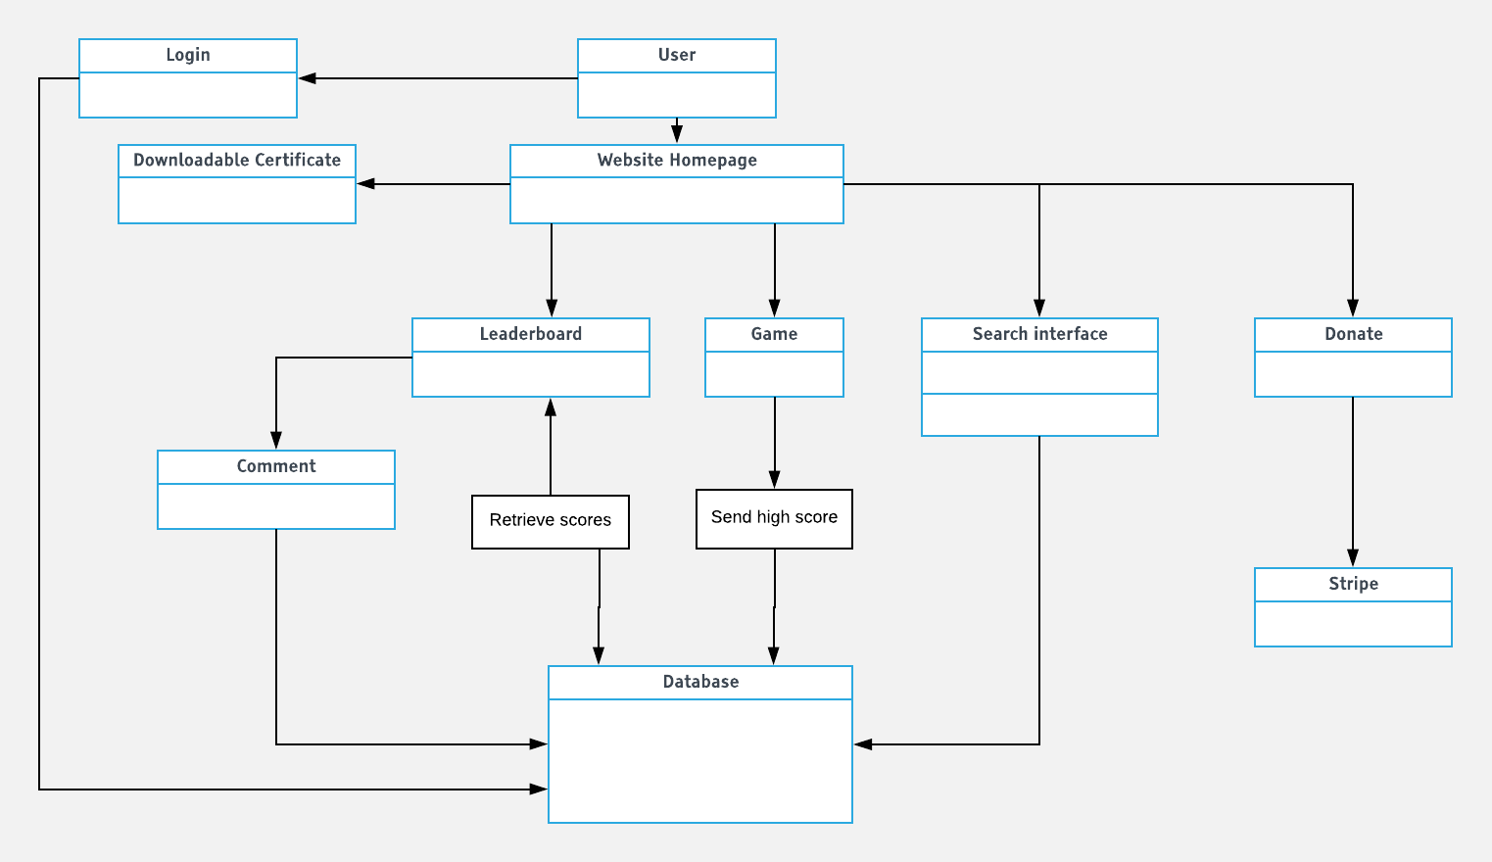

**Users**

|  |  |  |  |
| --- | --- | --- | --- |
| **Candidate Term** | **Not a Class bc** | **Class Name** | **Purpose** |
| **System Admin** |  | **SysAdmin** | **Control of the website and maintain function. Update all users and delete records**  **Unique attributes:**  **- Manage database**  **- Register accounts**  **- View/ Update Leaderboards**  **- Access Accounts** |
| **School Admin** |  | **SchoolAdmin** | **Authorize student and teacher accounts. Update and delete records**  **Unique attributes:**  **- Manage database**  **- Register accounts**  **- View/ Update Leaderboards**  **- Access Accounts** |
| **User** | **Abstract? Parent Class** | **User** | **Attributes:**  **- Register**  **- Login**  **- Read/ Write Comment**  **- Donate**  **- View Leaderboards**  **- System ID** |
| **General User** |  | **General User** | **Entity that allowed to register accounts**  **Has basic Attributes of User** |
| **Parent** |  | **Parent** | **Entity required to verify Student creation. Access to student data (Profile information, Score, read teacher notes, write comments )**  **Unique attributes:**  **- Inspect student/child progress(affiliated)**  **- Read student/child note(affiliated)** |
| **Teacher** |  | **Teacher** | **Entity in relation to Student. Access to student information. (Profile information, score, write notes, comments)**  **Unique attributes:**  **- Class ID**  **- Inspect class**  **- Write Notes (class affiliation)**  **- Inspect student/class**  **- Download pdf certificate** |
| **Student** |  | **Student** | **Entity in relation to teacher and parent. Allowed to play games**  **- Class ID**  **- Play game** |

|  |  |
| --- | --- |
| **Attributes** | **Datatype** |
| **Name** | **String** |
| **Entity ID** | **String** |
| **Password** | **String** |
| **Score** | **Int** |
| **Comments** | **String** |
| **Credit Card Info** | **String** |
| **Notes** | **String** |

**HLA Diagram**

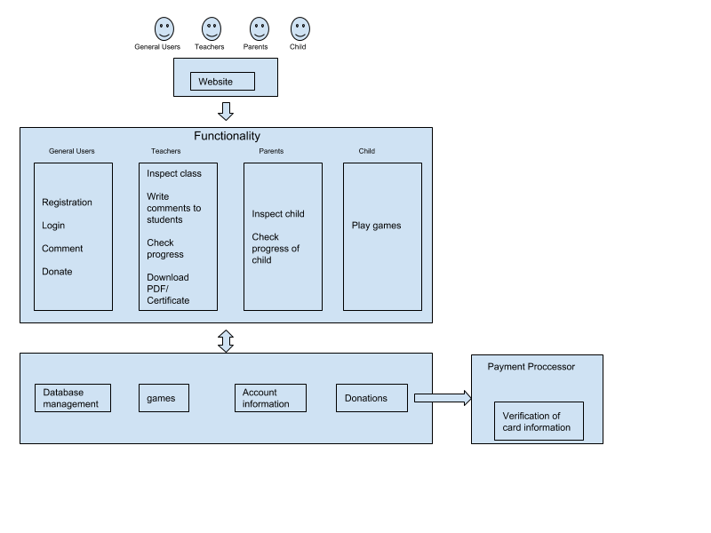

**Class Diagram**

